**Southern Song Dynasty Mirror from Xanadu, ca. 1279 CE**

**This Southern Song (南宋, 1127–1279) bronze mirror has an interesting story because it reflects the takeover of China by Kublai Khan, the first non-Chinese Emperor.**

**The mirror was cast in Xuzhou (徐州) a major city in Jiangsu province in central east China on the Huai Ho river but it was found in the Mongol stronghold of the Kublai Khan in the Minusinsk Basin. How did this mirror come to reside with the Mongols?**

**The answer is partly climatic and partly political. Because the Huai Ho river does not empty into the China sea, the area of Xuzhou was subject to seasonal flooding. This was exacerbated due to an Asian correlative to the Neo-Atlantic Altithermal Climatic Period, 800-1250 CE. Rainfall increased, the growing season was lengthened with a warming trend and a population expansion resulted in the 10th to the 11th centuries CE. As a result of the increased rainfall, the Huang Ho river changed its course due to silting and flowed into the lower Huai River valley near Xuzhou. The land became barren due to flooding, nutrient depletion and salination of the once fertile soil.**

**Concurrently, the Jin Dynasty to the north also experienced a population explosion and took control of northern China. Close on the heels of the Jin were the Mongols under Möngke Khan (1209 –1259) conquered the Jin aand took control of northern China in 1234. When Möngke Khan died, his younger brother, Kublai Khan (1215-1294) who was also the grandson of Genghis Khan, succeeded him. In 1271 Kublai Khan was proclaimed the Emperor of China.**

**When the Southern Song Dynasty was conquered in 1279 prestige goods flowed north to Kublai Khan's capital, Xanadu, where this mirror was found in what is now called Inner Mongolia, 275 km (171 mi) north of Beijing. This mirror attests to Kublai Khan's appreciation of key treasures of the Southern Song Dynasty to enhance his court.**

**The mirror displays typical signs of Southern Song mirrors of the 12th to 13th centuries CE: it is thin with a raised border, and is without designs except for two vertical inscriptions placed within in two frames. One might speculate as to the plainness of the mirror. After the Huang Ho began to change course during the Song Dynasty (AD 960–1279), heavy silting at the Yellow River estuary forced the river to channel its flow into the lower Huai River tributary. The region became barren thereafter due to persistent flooding, nutrient depletion and salination of the once fertile soil. An exact duplicate is in the Minusinsk Museum.**

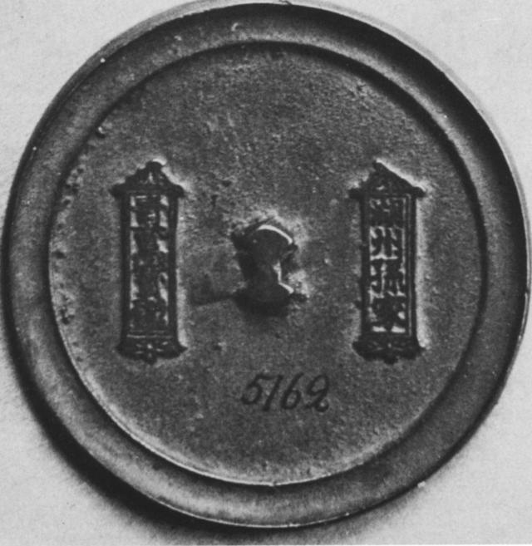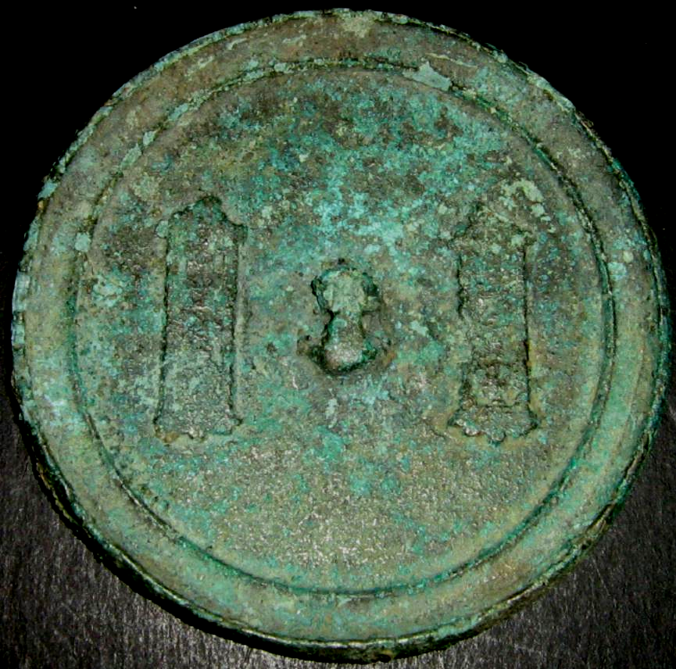

**Mirror with inscription, Diam. 8 cm. 12th-13th c. CE. Found in Minusinsk Basin. Left: *Minusinsk Museum*; right RJC Coll. Refs.: Wang Shih-lun, "T'an-t'an Hu-chou ching,"  *Wenwu,* 1958, no.6; E. Loubo-Lesnitchenko, Imported Mirrors in the Minusinsk Basin, Artibus Asiae, Vol. 35, No. 1/2 (1973), pp. 25-61.**